URL: <http://www.boulcotthospital.co.nz>

We believe that an environment which is welcoming, relaxing and personal will contribute to wellbeing. Our new facilities and refurbishments have been architecturally designed with those attributes in mind, and we have spacious recovery rooms including well appointed private rooms with garden views for those staying overnight. We provide those special touches that make the difference – flowers, artworks, great food and coffee are all part of the Boulcott experience – as well as ample car parking. Our staff play an active part in helping those who visit Boulcott to feel better. They are exceptional and thoughtful and we place great value on their desire to make a difference. In striving for excellence, we have earned the prestigious Quality Health New Zealand accreditation, which endorses our levels of care and service as of the highest standard internationally.

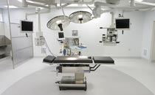 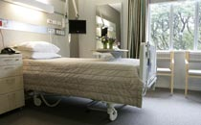 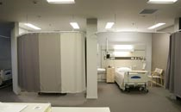

**Services:**

Orthopedic

Surgery

Gynecology

Ophthalmology

Plastic and reconstructive

General surgery

Cardiology

Gastroenterology

Otolaryngology

Urology

Oral maxillofacial

Fertility services

Pediatric

Vascular

Anesthesia

Rheumatology

**Doctor’s credentials**

**Doctors in orthopedic**

Mr. Brett L. Krause BSc, MBChB, FRACS, FRCS Edin (Orth), FNZOA

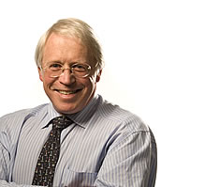

Brett is a New Zealand Medical Graduate from Otago, having qualified through the New Zealand Orthopaedic Association Registrar Training Scheme and is now in private practice at Boulcott Hospital with a public appointment to Hutt Valley District Health Board. Although a general orthopaedic surgeon dealing with arthroscopic surgery and hip and knee replacements, he has a special interest in shoulder pathology with perhaps 60-70% of his practice dealing with shoulders.

He is a Senior Clinical Lecturer to the Wellington Clinical School of Medicine and enjoys the opportunity to teach and undertake research. Brett has held the position of Secretary of the New Zealand Orthopaedic Association and remains interested in all aspects of orthopaedics.

To make an appointment for Brent Krause, phone 569 7555 Extn 710.

Mr. Robert Kusel MBChB, FRACS (Orth), Dip Obs

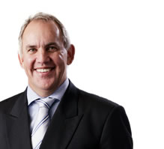

Rob trained at Otago University gaining his degree in Orthopaedics through the New Zealand Orthopaedic Association's training programme between 1985 and 1989. He continued his training at Princess Elizabeth Orthopaedic Hospital at Exeter, United Kingdom, 1989 - 1990 and Royal Brisbane Hospital 1990 -1992.

He was appointed to Hutt Hospital as an orthopaedic surgeon in 1992 and started in private practice at Boulcott Hospital the same year. A large proportion of Rob's practice involves arthroscopic surgery and hip and knee replacements but he has a special interest in lower limb surgery.

To make an appointment for Robert Kusel, phone 569 7555 Extn 710.

**Doctors in plastic and reconstructive**

Mr. Christopher Adams MBChB, FRACS

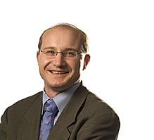

Chris graduated from Otago Medical School in 1990 and subsequently trained in Plastic and Reconstructive Surgery in Auckland, Hamilton and Wellington. He completed his F.R.A.C.S in 2001. He then spent two years in the United Kingdom completing a fellowship in Hand, Microsurgery and Burns Surgery in Chelmsford; an Aesthetic Surgery Fellowship in London; and a Breast Fellowship in Bristol.

Chris was appointed as a Consultant Plastic and Reconstructive Surgeon at Hutt Hospital in January 2004 where his main areas of interest are Acute and Reconstructive Burn Surgery, Breast Reconstruction and the surgical management of Melanoma.

He consults privately at Boulcott Hospital and in Wellington. In addition to General Plastic and Reconstructive Surgery with an emphasis on the above, he has a further interest in Aesthetic Surgery of the Breast, Facial Cosmetic Surgery and Hand Surgery.

To make an appointment for Christopher Adams, phone 569 7555 Extn 855.

### Mr. Charles Davis BHB, MBChB, FRACS

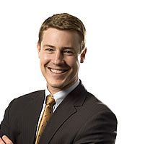

Examples of Mr. Davis’ work can be seen at [www.cosmetic-surgery.co.nz](http://www.cosmetic-surgery.co.nz)

Following specialist training in New Zealand, Charles completed a one year fellowship in Sydney under the mentorship of internationally renowned Professor Michael Poole, former head of the Oxford craniofacial unit performing paediatric craniofacial, skull base and orthoganathic surgery. A further six months were spent with Professor David David, current chairman of the International Society of Craniofacial Surgery (ISCFS) and head of the Australasian Craniofacial Unit. Charles is the first Australasian qualified Plastic Surgeon to have dual qualifications in both Plastic Surgery and Craniomaxillofacial surgery.

Following a period working as a specialist in Canberra and Newcastle, he was accepted as a fellow at the Scandinavian Centre for Craniofacial surgery in Goteborg, Sweden for a year under the renowned surgeon Claes Lauritzen, immediate past president of the ISCFS. Whilst there he commenced his PhD studying the Mechanobiology of the childs facial skeleton.

In addition to a wide ranging craniofacial experience, he worked alongside leading Swedish Plastic Surgeons gaining extensive hands on experience in cosmetic surgery of the face, breasts and abdomen.

He then did a 6 month travelling fellowship to centres of excellence in craniomaxillofacial, cleft, vascular anomalies and cosmetic facial plastic surgery, including London, Brussels, Philadelphia, Boston and Harvard Medical School, Toronto and Malaysia.

Charles leads the craniofacial team for Wellington and Christchurch Regional Plastic, Maxillofacial and Burn Surgery units. His public work is also heavily focussed on skull base, head and neck cancer surgery, jaw surgery, complex deformities of the face and ear deformities.

Charles has a major interest in ear reconstruction and studied with widely recognised world leaders in this field including Francois Firmin (Paris), Burt Brent (USA), David Gault (London), S-O Wickstrom (Sweden) and John Vandervord (Sydney).

Charles has written an article about [Aesthetic nasal reconstruction for Skin Cancer, read it here.](http://www.boulcotthospital.co.nz/gpnews/aesthetic-nasal-reconstruction-for-skin-cancer-by-charles-davis/)

His private interests mainly consist of skin tumours, facial cosmetic surgery, abdominal and breast re-shaping, liposuction, head and neck cancer and reconstruction after facial trauma.

To make an appointment for Charles Davis, phone 569 7555 Extn 724.

**Doctors in gynecology**

### Dr. Anju Basu MBBS, FRANZCOG

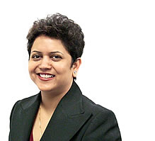

Anju is a New Zealand trained Obstetrician and Gynaecologist.

Anju has had the privilege to be trained by the leading Pelvic Reconstructive surgeon of Wellington in Urogynaecology and Pelvic Reconstructive surgery. She has extensive experience in the use of Mesh in reconstructive surgery for Pelvic organ prolapse and in the management of female urinary incontinence.

Her practice has a strong collegial interface with Urology, Colorectal Services and with the physiotherapists in the evaluation and management of women with pelvic floor disorders

Anju sees women with Gynaecological problems. Her special interests are:

* Urinary incontinence
* Vaginal prolapse
* Other Pelvic floor disorders
* Laparoscopic treatment of Endometriosis
* Menstrual disorders
* Fertility
* Colposcopy
* Pre pregnancy counselling for women with recurrent miscarriages
* PCOS and other medical problems

Anju is a member of AAVIS (Australasian Association of Vaginal and Incontinence Surgeons)

To make an appointment for Anju Basu, phone 569 7555 extn 719 or e-mail [info@boulcotthospital.co.nz.](mailto:info@boulcotthospital.co.nz) You can also fax her on 567 0041.

### Dr. Meera Sood MBBS, MRCOG, FRANZCOG

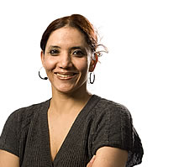

Meera graduated from Punjab University, India, in 1996.

She is a member of Royal college of Obstetricians and Gynecologists, UK (MRCOG) and Australian and New Zealand College (FRANZCOG).

Meera’s special interests are in:

* Colposcopy
* Laparoscopic surgery
* Menstrual disorders
* Infertility
* Pelvic floor surgery

Meera has written an article about [Current minimal access techniques in the treatment of heavy menstrual bleeding, read it here.](http://www.boulcotthospital.co.nz/gpnews/current-minimal-access-techniques-in-the-treatment-of-heavy-menstrual-bleeding-by-meera-sood/)

To make an appointment for Meera Sood, phone 569 7555 Extn 719.

**Doctors in general surgery**

Mr. Hugh S. Cooke MB ChB, FRACS

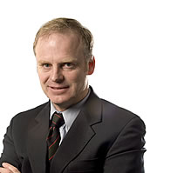

Hugh is a General Surgeon with special interests in hernia, gallbladder and colorectal surgery. This includes laparoscopic techniques for cholecystectomy and hernia repair as well as colonoscopy. Other aspects of his practice are varicose vein surgery, minor operations and thyroid surgery.

Hugh gained his medical degree at Otago University in 1979. His post fellowship experience was undertaken in England over four years where he worked in Hull, London and Birmingham. He worked for two years at the Wellington Clinical School of Medicine specialising in colorectal surgery, and is working part time at Hutt Hospital and in private practice.

To make an appointment for Hugh Cooke, phone 569 7555 Extn 897.

Mr. David Gaskell MB ChB, ChM, FRCS Edin, FRACS

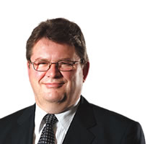

David trained in the United Kingdom at Manchester and Edinburgh, qualifying as a General Surgeon. He has been living in New Zealand since 1994 with his wife and children. He has been senior lecturer in surgery at the Wellington School of Medicine for the last five years, and is now in private practice. David lives in the Lower Hutt area, continuing his private practice with a special interest in Breast Surgery.

To make an appointment for David Gaskell, phone 569 7555 Extn 840, or phone 570 1421.

**Doctor in cardiology**

Dr. Tim O'Meeghan B.Med Sc, MBChB, FRACP

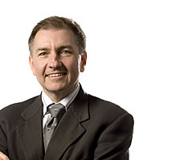

Tim trained at Greenlane Hospital, Auckland and in Sydney, Australia. His interests are in general cardiology, but he has a particular interest in heart failure and echocardiography.

Presently Tim is clinical Head of Department at Hutt Hospital Cardiology and has his private practice at Boulcott Clinic.

Tim is married with four children.

To make an appointment for Tim O'Meeghan, phone 381 8115.

Doctors in gastroenterology

### Dr. Vinton Chadwick MA, MSc, MD, FRCP, FRACP

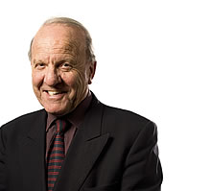

Vinton Chadwick is a Gastroenterologist and Endoscopist at Boulcott Hospital. He has a special interest in Irritable Bowel Syndrome and Inflammatory Bowel Disease and Colorectal Cancer. His medical training was at Cambridge University, University College Hospital, London; Mayo Clinic, Rochester, US; and the Royal Postgraduate Medical School, Hammersmith Hospital, London. He was Head of Gastroenterology at the latter institution before being appointed as a Professor of Medicine at the University of Otago.

To make an appointment for Vinton Chadwick, phone 569 7555 Extn 776.

* For more information on bowel cancer, visit [bowelcheck.co.nz](http://bowelcheck.co.nz)

Dr. Ian Wilson FRACP

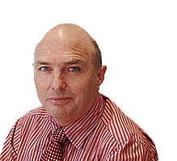

After 15 years providing gastroenterology services in Wellington, Dr Ian Wilson is now available for consultation and endoscopy services at Boulcott Hospital.

Ian offers careful evaluation of patient's symptoms, co-ordinated targeted investigations and where possible, an evidence based management plan.

Covering all aspects of gastroenterology including:

* Assessment, investigation and management of gastrointestinal symptoms.
* Evaluation of oesophageal disease and dysfunction and investigation of dysphagia.
* Assessment and management of dyspepsia.
* Diagnosis and treatment of malabsorption syndromes including diseases of the pancreas.
* Evaluation and treatment of liver disease.
* Investigation and management of lower bowel disorders and colonoscopy screening for colorectal cancer.

Boulcott Hospital offers a state-of-the-art endoscopy unit providing:

* Upper GI endoscopy.
* Colonoscopy.
* Therapeutic modalities including polypectomy, mucosal resection and treatment of other mucosal disorders.

Boulcott Hospital is an accredited Southern Cross provider.

To make an appointment for Dr Ian Wilson, phone 576 1707.

**Doctors in ophthalmology**

Dr. Nina Ashraff MB ChB, FRCOphth, FRANZCO

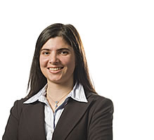

Nina Ashraff is an eye surgeon with a special interest in glaucoma and cataract surgery.

She is a Fellow of the Royal Australian and New Zealand College of Ophthalmologists, and a Fellow of the Royal College of Ophthalmologists, United Kingdom.

Nina graduated from Leeds University Medical School, UK, and did her post graduate specialist training at Manchester Royal Eye Hospital, UK. She spent 18 months doing cataract and glaucoma sub-specialist training at Manchester and Wellington.

To make an appointment for Nina Ashraff, phone 499 4940.

### Mr. Kolin Foo MB ChB, FRANZCO

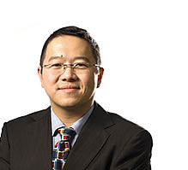

Kolin is an ophthalmologist (eye specialist). He graduated from the University of Otago in 1993 and subsequently received his ophthalmic training in Wellington and gained FRANZCO (specialist qualification) in 2002. He underwent two further years of subspecialty training in Australia and UK before returning to Wellington.

He trained with world renowned specialists in Australia and UK in the field of cataract surgery, medical retina and vitreoretinal surgery. Kolin was appointed as a vitreoretinal and cataract surgeon at Wellington Hospital in July 2004. Kolin was the first person to introduce photodynamic therapy (PDT) to Wellington for the treatment of macular degeneration.

Kolin consults in general ophthalmology conditions with a special interest in:

* General ophthalmology
* Sutureless, micro-incision cataract surgery
* Management of macular degeneration including photodynamic therapy (PDT) laser treatment
* Retinal and macular surgery

To make an appointment for Kolin Foo, phone 566 7009, or e-mail [info@boulcotthospital.co.nz](mailto:info@boulcotthospital.co.nz)

### Doctor in Otolaryngology

Dr. Catherine M Ferguson MBChB, FRACS

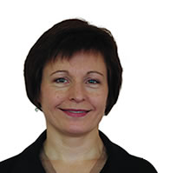

Cathy Ferguson is trained in general Otolaryngology. She has had a special interest in head and neck surgery. Enthusiastic about all areas of ENT practice, she has a particular interest in Paediatric ENT problems and can do Audiograms on children over 4 ½ years.

Common reference conditions include:

* Nose and sinus disease
* Chronic middle ear disease
* Voice disorders
* Thyroid and salivary gland disease
* Vertigo
* Paediatric ENT
* Snoring

To make an appointment for Cathy Ferguson, phone 499 3900.

**Doctor in urology**

Mr. Grant Russell MBChB, FRACS Urology

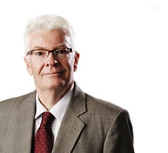

Since commencing in practice in Wellington, Grant has taken an interest in the Hutt Valley and has regular clinics and operating sessions at Boulcott Hospital. Grant also has regular clinics at Boulcott Hospital’s consulting rooms in Paraparaumu. Grant performs a full range of urological procedures in the operating theatre.

Grant has particular interests in:

* Prostatic Disease
* Minimally invasive surgery
* Stone disease

To make an appointment for Grant Russell, phone 04 473 6207.

**Doctor in fertility services**

Dr Andrew Murray FRANZCOG, CREI

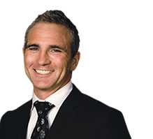

Medical Director of Fertility Associates Wellington

Andrew is a Fellow of the Royal Australia and New Zealand College of Obstetricians and Gynaecologists, having originally trained in New Zealand. He went on to complete a two-year fellowship in Reproductive Endocrinology and Infertility at Monash IVF, Melbourne, Australia. During this time he developed a strong interest in advanced operative laparoscopy and hysteroscopy. Andrew has also trained in tubal microsurgery and performs reversal of sterilizations and vasectomies.

Andrew is a Senior Lecturer at Wellington School of Medicine, University of Otago and is one of the Consultant Obstetricians and Gynaecologists at Capital and Coast Health, Wellington Hospital. He also is on the New Zealand Committee for the Royal Australia and New Zealand College of Obstetricians and Gynaecologists. Andrew has a clinic at Boulcott Hospital where he sees gynaecology and infertility patients.

To make an appointment for Andrew Murray, phone 384 8401

**Contact us:**

**Boulcott Hospital**,  
PO Box 31-459, Lower Hutt, New Zealand  
**Telephone:** 64 4 569 7555  
**Fax:** 64 4 567 0041  
**Email:** [info@boulcotthospital.co.nz](mailto:info@boulcotthospital.co.nz)